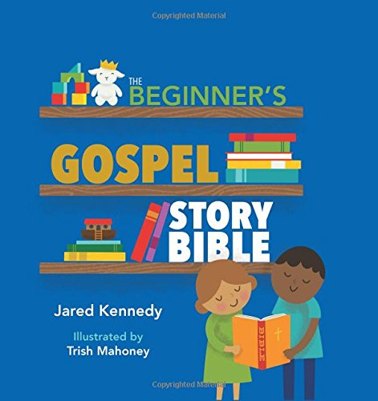
The Beginner’s
Gospel Story Bible Curriculum
Overview for Twos-PreK Parents

This year, your child will be studying God’s truth using The Beginner’s Gospel Story Bible in their classroom. We will take the children through key stories in the Old Testament during most of the first semester, and start the New Testament just in time for Jesus’ birth for our Christmas Celebration. We will focus on how God is the hero of each and every story, and how each story is part of the whole rescue plan that God has in place for His people. There are three key truths we focus on throughout all of preschool: God loves me, God is powerful, and God wants to be my friend.
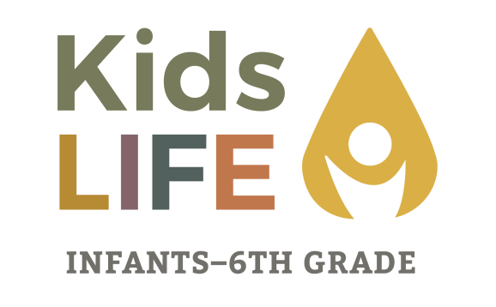
We have chosen this popular children’s Bible, as a desire to partner with New Hope families by using a resource that is readily available. We recognize that the responsibility, as well as the privilege, of nurturing the faith of children rests primarily on parents. Parents have the greatest opportunity for teachable moments – everyday situations in which the truth of God’s Word can be applied. Faith nurturing should not be seen primarily as a classroom experience, but rather as a consistent weaving of spiritual truth into everyday life. New Hope desires to partner with parents, and choosing a resource that might already be on your bookshelf could allow you to connect better with what your children are learning, allowing you to feel more equipped to talk to your children about Truth. I urge you to consider purchasing this children’s bible (or any others!) to have at your own home if you don’t already own a copy. What a wonderful opportunity to reinforce the lessons being learned at KidsLIFE.

KidsLIFE is so excited to have your child join us! I am happy to answer any questions you might have. Also, we would love for you to join our “New Hope KidsLIFE” Facebook Group. It is a great resource for upcoming events and reminders, parent resources, and to help you stay connected with what our children are learning about Jesus.

Kira Buser
Director of KidsLIFE
kirabuser@newhopeks.org
785.317.3314

